Xml-vs-html – major diferences

 | XML | HTML
Have Root element | yes | yes
tags | Can create whatever we want | Have pre-defined tags
Case sensitiveness | yes | No
White spaces | Preserve white spaces as same as | Concat to single space
Character entities | need | need
comments | <!-- comment --> | <!-- comment -->

character entities:- some character cannot be inserted directly to XML or HTML. Therefore, need character entities
https://dev.w3.org/html5/html-author/charref

headers
several - mind – types
text/html, text/css , application/xml, application/json, application/swwformurlencoded, multipartformdata

send http request using intellij
tools → HTTP client → test restful webservice
ctrl + alt + shifr + insert
type → Get <url>

Json

json is a text/ string.
with the introduction of json → xml was not used
JavaScript Object Notetion

js object – with properties and values
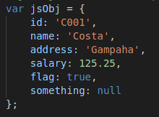

in json obejst
string represent only “” (double quotes)
all properties are mentioned as string

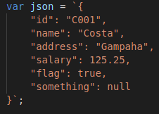

data types that valid in jason:-
boolean, number , string, null
all other types are not valid

two main functions – to convert to js and to json
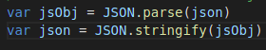

Three types of json
1. json values (string (“”), number, boolean (true, false), null)
2. jsong objects
3. json arrays

print number and string
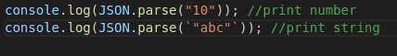

GSON, Jakson, jsonp, jsonb are used to guide java, about json

most of the google proudts are used java like drive, office package

There are two java specifications,
JSONB, JSONP
Reference Implementation - This is the main thing. Others derived from this. (like open jdk)

jcp – java community process

CRUD operation and override methods
check google:- mdn http post, mdn http get – for more details
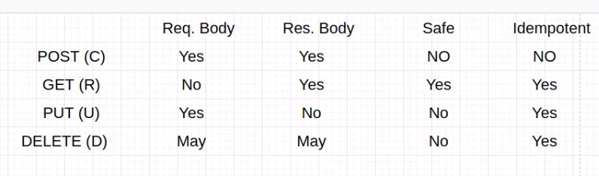

idempotent and non-idempotent
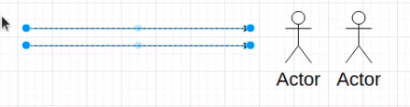

Idempotent: If an identical request can be made once or several times in a row with the same effect while leaving the server in the same state. In other words, an idempotent method should not have any side-effects

Status code
mdn status code
https://developer.mozilla.org/en-US/docs/Web/HTTP/Status

Different categories
2xx – success
201 – created
204 – no content
3xx – Redirectin
4xx – client errors
400 – bad reqest
404 – not found
5xx – server errors
500 – Internal server error
503 – service unavailable

